$20

Mail-In
Rebate
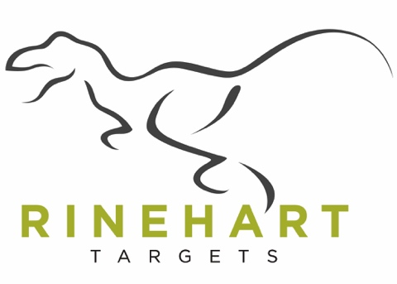

Offer Valid August 1, 2022 – September 30, 2022

To receive your rebate by mail follow these redemption conditions of acceptance:

- Purchase any of the following products between 8/1/22 and 9/30/22:
  - Eighteen to One:18-1 (#18110)
  - Jimmy Big Tine (#20011)

- Fill out the form below.
- Mail the rebate form along with the original
purchase receipt with the purchase date and UPC circled.

- Mail the information to:
Rinehart Targets
$20 Rebate Offer
1809 Beloit Ave
Janesville, WI 53546

Important Information
Photo copy your entire submission for your records.

Must be postmarked by November 1, 2022 to be valid.

Your qualifying rebate check will be mailed within 4-6 weeks of the postmark date.

Name _________________________________________ Purchase Date _______________

Address ______________________________________________________________________

City/State __________________________________________ Zip ______________________

Phone _____________________________ Email _____________________________________

Product ________________________________ UPC _________________________________

Signature ________________________________________ Date _______________________

